Chasing the American Dream: Income Inequality and Education

Chasing the American Dream: Income Inequality and Education
We have a problem in the United States and around the world. For most of us it does not seem to affect our daily lives yet that is just a façade that blinds us to the facts. Throughout the bulk of our lives we are lead to believe that we live in a land of opportunity where we can attain any of our dreams. The conditions you are born to and raised in greatly impact your ability to prosper in the United States, it is hard at this point to assume otherwise. It is not all doom and gloom, there are ways for the impoverished to better their circumstances. Money controls the levels of poverty, power controls the ability of those with money to push their ideology and education changes the dynamics of both. To best understand this, we will delve into how money and power affect people, then discuss how education affects both.
The gap in income inequality can be described as the origins or cause of poverty, which can be broken down into 4 major parts. The first part involves personal or individual deficiencies which is where the individual is responsible for their own poverty, such as making bad decisions and choices that lead directly into poverty. The second is described as the cultural belief system that promotes subcultures of poverty. This is done by passing down through generations the belief systems that keep them in poverty by not promoting the ideals and values that lead to prosperity. The third system is that of social, economic and political distortions that lead to the creation of barriers for the individuals of specific groups or races. This includes criminalizing of certain groups, making it harder for groups to get a better education and training. The fourth origin of poverty is circumstantial origins whereas poverty is look upon as a cycle. This is where there is no money flowing in, which in turn means that no money can flow out and thus you cannot create new opportunities for the community. An example of is this is where you have no money flowing into the community therefore the individuals have no money to spend and in turn there can be no new businesses started because there is no money flowing in and therefore stays in a perpetual state of poverty which it cannot bring itself out of (Villanueva, 2017). The reality is that it is not as easy as it sounds to get out of poverty and for many people it is a gargantuan task breaking away from their individual circumstances holding them back. Since the importance of money is fundamentally integrated into our system by who controls it. Who lends it controls who can get it and often controls what they are able to do with it (Bracking, 2009, pgs. 8-9). It becomes a vicious cycle for those left in the bottom to break since it becomes very hard to get the financial backing. While the wealth and power gap is attributed to the financial wellbeing of the society it also impedes on the poor’s ability to be heard.
The power aspect is greatly attributed and distinguished by the ability to control the opinion of the people for which:
No one could reasonably dispute that, for the much of the latter half of the twentieth century, economic power and the ability to get oneself heard became significantly intertwined. The simple realities were - and, to a certain extent, may still be - that one must control or at least have meaningful access to institutionalized modes of communication in order to reach and extended audience. Yet for the large majority of individuals and organizations the cost of doing so have generally been prohibitive. Not surprisingly, then, most effective means of modern communication have been controlled largely be economically powerful entities or individuals. The result, some have argued, has been a harmful inequity in the relative ability of members of the populace to communicate their messages and a resulting impoverishment of the scope and substance of public debate (Redish, 2001, pg. 147).
If history has shown anything is that as the inequality gap widens and the voice of the people shrink the more discord there is for the common person and the more likely the scenario that a government is toppled by the oppressed. While park avenue is viewed as the richest it does not mean that this kind of power and influence is not asserted throughout all states and communities. While this exemplifies the power asserted at the highest reaches of our government those throughout the nation are able to control at much more fundamental levels that affect their individual local governments (Gibney, 2012). There is one thing that we can be sure of and it is that the middle class is the life and blood of any government and as the gap for the rich widen the more the middle class shrinks in a society. There is one major factor that can greatly affect the ability of the people to shrink the gap: education (Gibney, 2012).
It is fundamentally recognized that the participation of the people and ability to break away from poverty is through education. This is exemplified in the following charts:
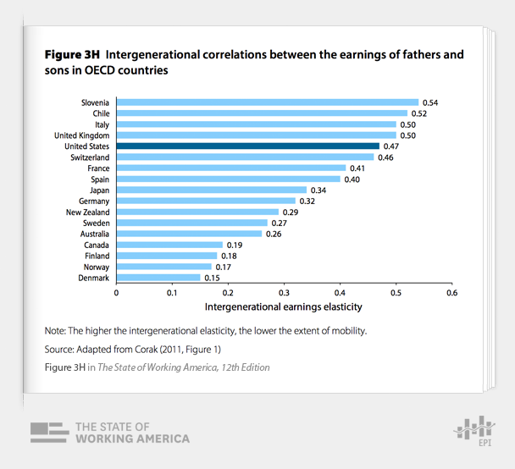
Figure 1. Upward mobility for different countries. Copyright 2016 Economic Policy Institute.
This chart which describe the upward mobility from one generation to the next and by:
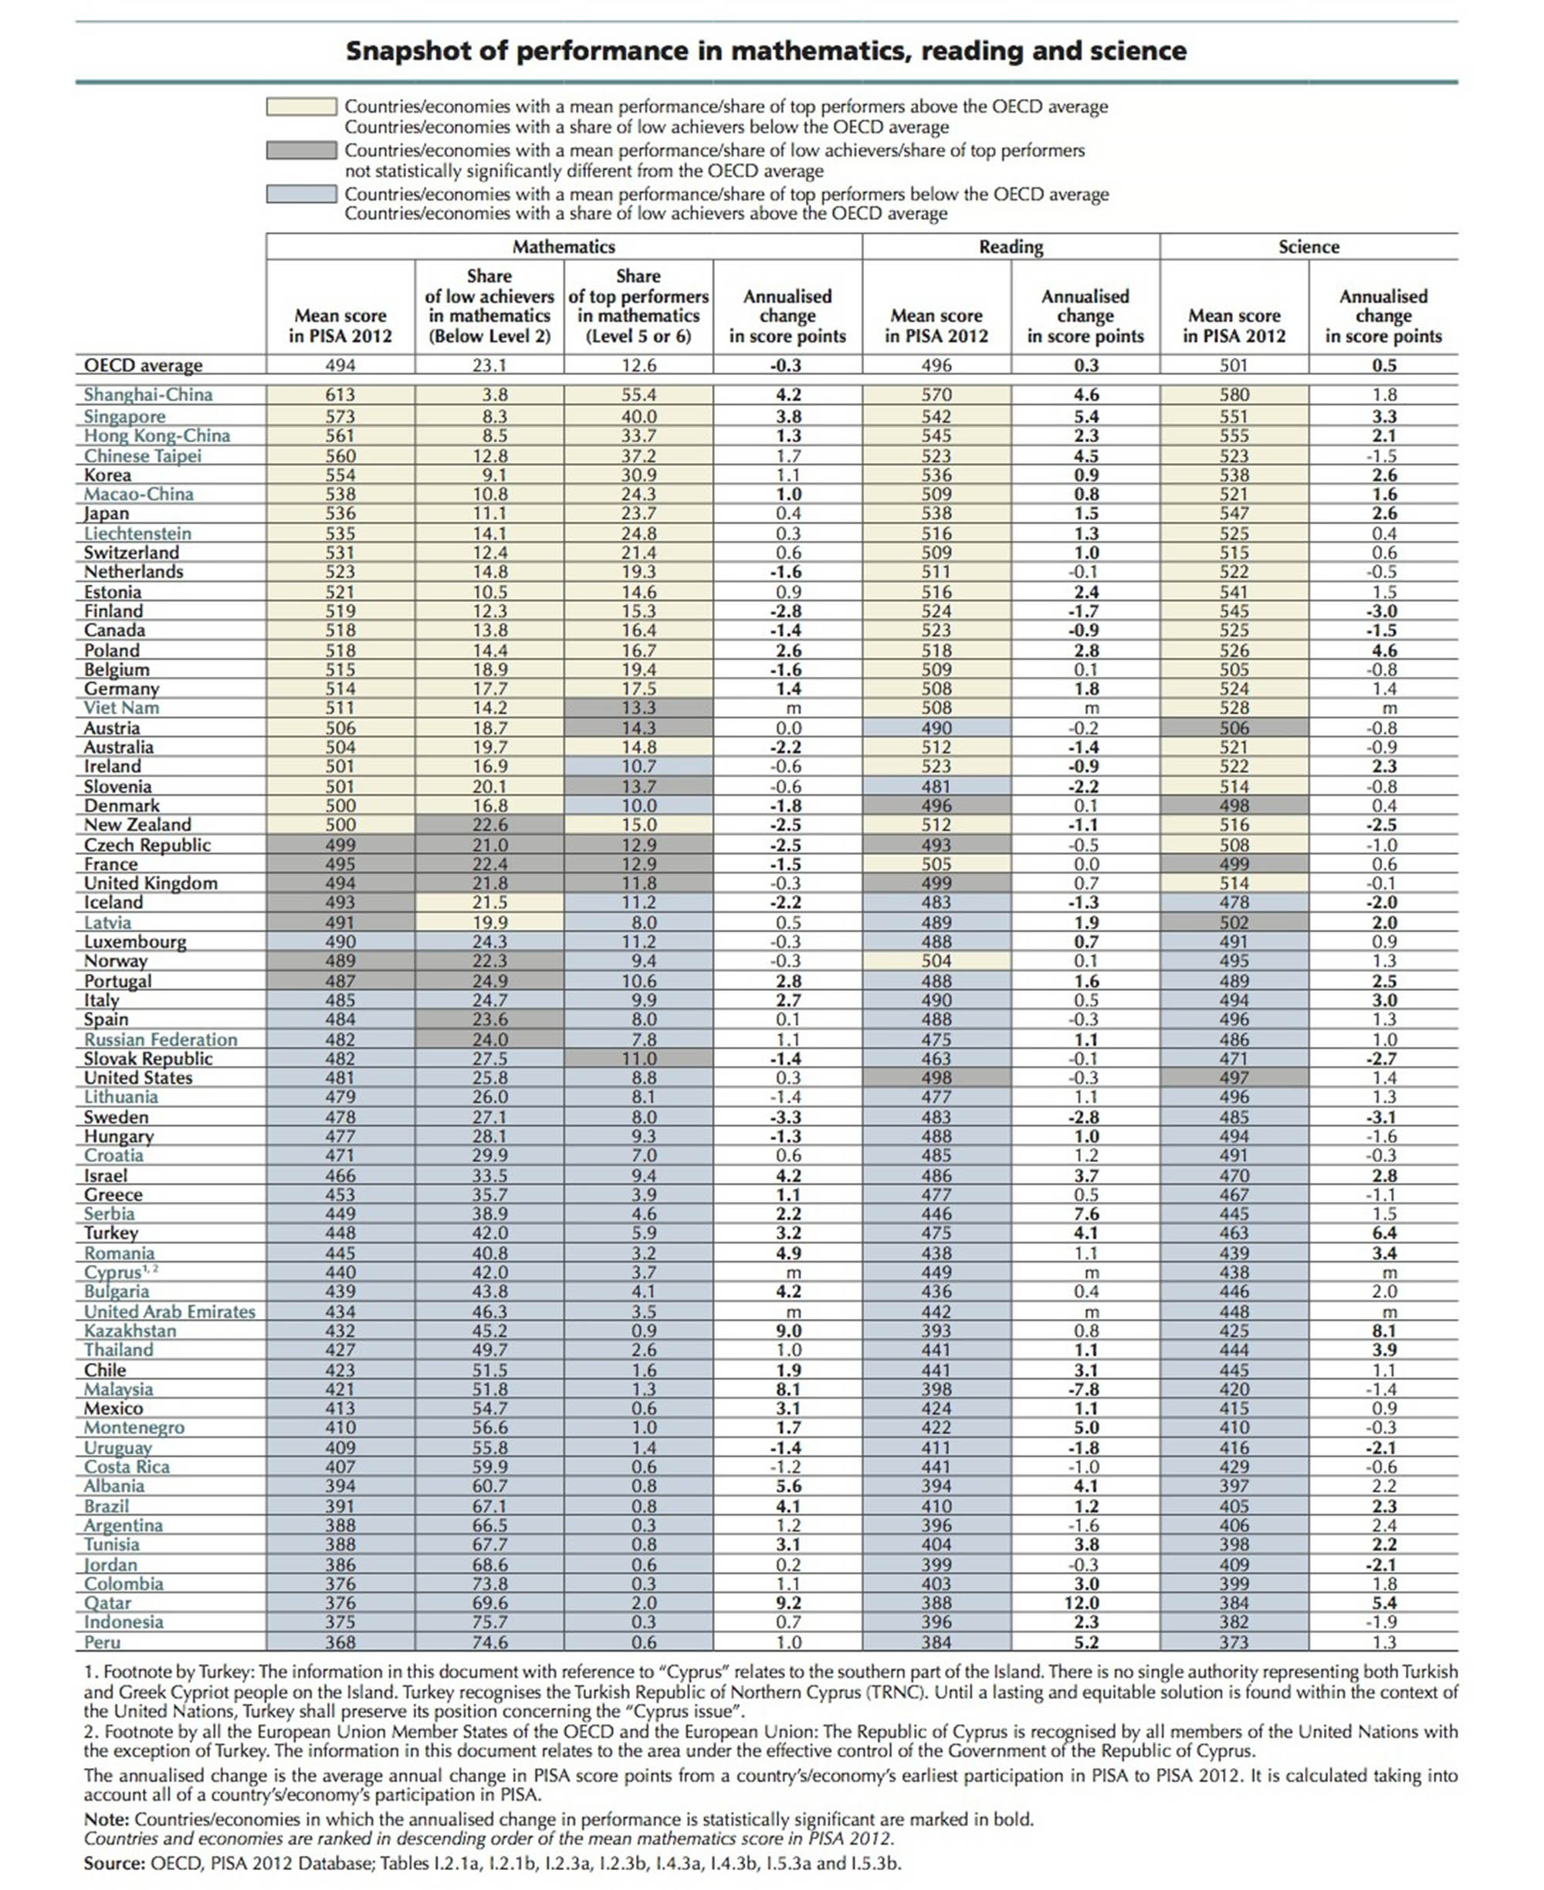
Figure 2. Education levels around the world. Copyright The Atlantic Monthly Group.
This chart describes the education level for each country. What is very interesting about these charts is that there seems to be a correlation, by looking at the charts it seems to show that there is a connection between upward mobility and education levels at the national level. "The government's role is to provide more opportunities by providing them the necessary factors of production, particularly financial and physical capital, to get them out of this trap." This can especially be done through the addition of a better education system which is widely believed to be the best way to change the income inequality in our nation (Villanueva, 2017).
It is easy to see how education can change the ability of people to gain access to more money, but with it also comes a second effect. Education also raises the intellectual level of the people and powers their ability to see beyond rhetoric and sound bites. The more educated the person, the different they perceive how the world. The greatest change our world has undergone was during the Renaissance Era, during which time the people began to become more enlightened through education and communication. In this time, the world went from a very huge power gap and saw themselves fighting for more equality, which reshaped Europe. The reality of things is that as things stand right now the gap will only widen and it should be our democratic governments pursuit to give people the ability to shorten this gap and this can best be done through education.

References
Bracking, S. (2009). Money and Power: Great Predators in the Political Economy of Development Third world in global politics. Pluto Press. Retrieved from http://site.ebrary.com/lib/interpuertorico/detail.action?docID=10479972
Gibney, A. (Director). (2012, November 12). Park Avenue: Money, Power & the American Dream [Video file]. Retrieved from http://www.pbs.org/video/2296684923/
Gould, E. (2016). Upward mobility for different countries[Chart]. Retrieved from http://www.epi.org/publication/usa-lags-peer-countries-mobility/
Redish, M. H. (2001). Money talks speech, economic power, and the values of democracy. New York: New York University Press. Retrieved from http://site.ebrary.com/lib/interpuertorico/detail.action?docID=10032537
Ryan, J. (2017). Education levels around the world[Graph]. Retrieved from https://www.theatlantic.com/education/archive/2013/12/american-schools-vs-the-world-expensive-unequal-bad-at-math/281983/
Villanueva, J. P. (2017, March 16). Villanueva: How to end poverty?. SunStar Baguio. Retrieved from http://www.sunstar.com.ph/baguio/opinion/2017/03/16/villanueva-how-end-poverty-531378

